Cultivated Tobacco

(Nicotiana tabacum)

1:2 scale(Size is approximate about 2 feet tall and 30 cm long leaves.)

- Leaves average 23-30 cm wide and 55-60 cm long (Canadian Encyclopedia)

-A well grown plant will top at 39-51 inches tall(tobacco.yaia) 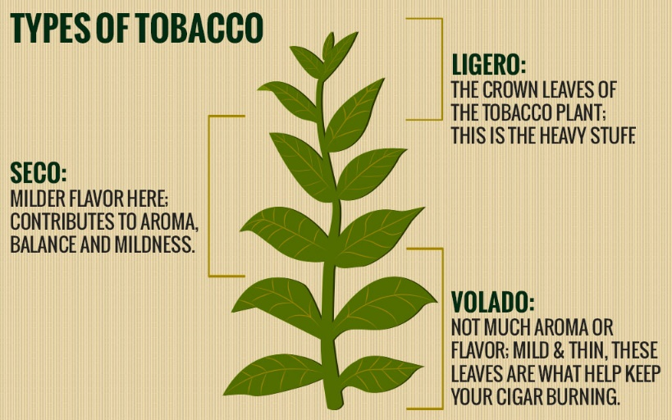

Biome:

-The Tobacco belt runs around Norfolk County and eastern Elgin County.

-Tobacco belt is around the mixed wood plains of Ontario.

- About 90% of tobacco is grown there.

- Also the industry has seen a 144% rise since 2008.

-Due to changing climate from winter-summer hotbeds are usually used.

-Tobacco requires a stable and dry climate (20oC – 30oC)

-They require lots of fertilizations and lots of pesticides to create the optimal plant

Properties:

-The nicotine in tobacco is one of the first natural insecticide and pesticides.

-Literally every part of the tobacco plant contains nicotine besides the seed protecting the plant from any sort of small pest or insect.

-There is also a theory where tobacco created nicotine so humans would cultivate it.

-Another useful property is tobacco uses mutualism to protect itself. When tobacco’s predator that is immune to the nicotine starts to eat the herb the tobacco creates a stench and the tobacco’s predator’s predator knows the smell and works with the tobacco to catch and eat the predator. So the tobacco plant is safe while the predator’s predator is fed.

Importance in Ecosystem:

-This plant is an important plant for the ecosystem for many organisms

- Like above the tobacco works with secondary consumers to protect them from the primary consumers

-The plant also controls the population of insects by killing them with nicotine.

- However the cultivation of the plant has created multiple problems with the environment

-Too much fertilizer has generated lots of phosphates in nearby bodies of water

-Lots of wood is required to cure tobacco.

- Too many plants in a dense area can result in a lot of nutrients leeching into the ground causing serious health risks to nearby farms or bodies of water.

Medicinal Properties

-Many Native Americans also used tobacco for medicinal uses but the act of smoking the herb did not start until the Spanish explorers arrived they would “snuff” the ground up tobacco.

-Tobacco has a bad medicinal track record but can be used for multiple different health problems

- In India tobacco is used as toothpaste by grinding the tobacco to a powder and then rubbing it on their teeth

- Now a day’s tobacco is sometimes used to treat autoimmune and inflammatory diseases and even diabetes.

- Scientists have genetically modified the plant where it can help counteract some diseases.

-Tobacco has also been shown to treat Alzheimer’s and some cases of Parkinson’s where subjects are injected with strong doses of nicotine.

-Tobacco can be dried and turned into a powder to act like an insecticide when rubbed onto a person’s head it can help kill lice.

-Many mentally ill people with schizophrenia and add might take

-If a venomous snake bites you then 50 mg of tobacco can be mixed into a paste and diluted with about 1L of water. When the subject drinks the tobacco liquid he will vomit up the venom.

- Tobacco also has Vitamin C which is helpful for skin infections and eczema which so when chewing tobacco is chewed it can expel Vitamin C and help fight skin infection.

Human Impacts

-The introduction of tobacco to European explorers has created a massive market for the product.

Pros.

-Mass cultivation of plant allowing the plant to thrive.

-The first GMO was tobacco and now the plant usually contains pesticides, insecticides, antibiotic resistant, resistance to fungi, herbicide tolerance. Also it is mixed with an ammonia which will make the nicotine 35 times stronger to increase the defense of the plant.

-On tobacco farmers land many have specifically hunted down the tobacco plants predators allowing the surrounding tobacco plants to thrive.

-Also the plants are growing much bigger due to the lack of competition and more ideal conditions for the plant allowing easier, more respiration and photosynthesis.